ANNEX

to the Resolution of the Central Electoral Commission of the Republic of Uzbekistan

№ 1066 from 14 April 2021

**REGULATION**

**on the procedure for organizing activities of precinct election commissions to conduct elections of the President of the Republic of Uzbekistan**

This Regulation determines the procedure for operation of precinct election commissions to conduct elections of the President of the Republic of Uzbekistan (hereinafter - precinct election commissions) in accordance with the Electoral Code of the Republic of Uzbekistan (hereinafter - the Electoral Code).

**Chapter 1. General Provisions**

Composition of the precinct election commission is approved based on the decision of the district election commission to conduct elections of the President of the Republic of Uzbekistan (hereinafter - the district election commission).

2. Member of a precinct election commission may be relieved of his/her duties based on a decision of the appropriate district election commission in the following cases:

- based on a personal request;

- in case of termination of powers;

- in case of violation of requirements of the Electoral Code or systematic failure to fulfill obligations.

In this case, the fact of violation of requirements of the Electoral Code or systematic failure to fulfill duties by a member of a precinct election commission shall be documented by the means of an act of the precinct election commission of which the respective individual is a member.

3. Based on the decision of the precinct election commission, a chairman, deputy chairman, secretary or other member of the commission may be relieved of work or service responsibilities in preparation and conduct of elections at the expense of funds allocated for elections while retaining the average monthly salary.

4. Member of a precinct election commission cannot be dismissed from his/her position at the initiative of an employer or transferred to another job without his/her consent during the election campaign until the end of his/her term.

5. Chairman, deputy chairman, secretary and members of a precinct election commission shall be issued an identification document in accordance with Annexes 1, 2, 3 or 4 to this Regulation.

Identification document of the chairman of the precinct election commission shall be signed by the chairman of the district election commission and certified by the district election commission's seal.

Identification documents of the deputy chairman of the precinct election commission, secretary of the commission and its members shall be signed by the chairman of the precinct election commission and certified by the precinct election commission's seal.

**Chapter II. Organization of Activities of the Precinct Election Commission**

6. Precinct election commission shall operate based on the principles of legality, collegiality, transparency and fairness.

7. Meetings, which are organized as required, shall be considered as an organizational form of operation of the precinct election commission.

Meeting of a precinct election commission shall be deemed validly convened if at least two thirds of the total number of commission members attend it on the day of the meeting.

8. Meeting of the precinct election commission may be convened at the initiative of a chairman or at the request of at least one third of the total number of members of the commission.

9. Decision of the precinct election commission is made by open voting of the majority of the total number of commission members. In case of equality of votes, the chairman shall have a casting vote.

10. Precinct election commission implements its activities in an open and transparent manner.

Meeting agenda, first names, last names, patronymics of the participating members of the commission, voting results on each agenda issue, final decisions shall be reflected in the protocol of the meeting.

Meeting protocol is signed by the chairman and secretary.

Adopted decision, conclusions and other documents as well as individual opinions of commission members on separate issues are attached to the meeting protocol.

11. Participation of members of higher commissions, agents of presidential candidates (hereinafter - candidates), observers and authorized representatives of political parties, mass media, observers from citizens' self-government bodies, other countries and international organizations in meetings of precinct election commissions is possible.

Representatives of local administration, public associations and others can be invited to the meetings.

12. Authorized representatives and observers from political parties that nominate candidates for the President of the Republic of Uzbekistan as well as representatives of mass media, citizens’ self-government bodies, other countries, observers from international organizations have the right to take part in all activities of the precinct election commission related to preparation and conduct of elections, including being at polling stations and counting votes.

Their powers shall be confirmed by appropriate documents.

**Chapter III. Powers of the Precinct Election Commission**

13. Precinct election commission:

compiles a list of voters at a polling station;

familiarizes voters with the voter list, accepts and reviews requests about errors and inaccuracies in the list and makes a decision on amending the list;

accepts completed ballot papers in sealed envelopes from voters who cannot be present at their place of residence and vote on election day and vote early;

keeps population informed about the election day and place of voting;

ensures that a building is equipped with secret voting booths or rooms, ballot boxes as well as other equipment in accordance with Annexes 5, 6 and 7 to this Regulation;

organizes voting at a polling station on an election day;

organizes voting at the place of residence based on requests of voters who are unable to come to the polling station due to health issues or for other reasons;

counts votes;

reviews applications of the voters and other participants of the electoral process and makes decisions on them.

Exercises other powers in accordance with the Electoral Code and this Regulation.

14. Chairman of the precinct election commission:

manages activities of the precinct election commission;

convenes meetings of the precinct election commission, presides over them and determines the meeting procedure;

distributes responsibilities among members of the commission;

on behalf of the precinct election commission engages with state bodies, international organizations, public associations;

organizes equipping of the building of the precinct election commission and voting room;

signs decisions of the precinct election commission, identification cards of the deputy chairman, secretary and members of the precinct election commission and other documents;

distributes requests of individuals and legal entities among members of the commission for consideration;

organizes and coordinates visits of members of the precinct election commission to verify accuracy of information about voters who are included into the voter list;

determines duties of the members of the precinct election commission for the voting day;

on behalf of the commission engages with observers, authorized representatives of political parties, citizens' self-government bodies as well as observers from other countries and international organizations;

informs the district election commission or law enforcement bodies of identified cases of violations in the process of preparation and conduct of elections;

After announcement of outcomes of election of the President of the Republic of Uzbekistan, the commission submits relevant documents to city and district departments of state archives and city and district khokimiyats;

Exercises other powers in accordance with the Electoral Code and this Regulation.

If the chairman of the precinct election commission is unable to perform his/her duties or in the absence of the chairman of the precinct election commission, his/her powers shall be transferred to the deputy chairman or one of the commission members based on the decision of the precinct election commission.

Deputy Chairman of the Precinct Election Commission:

coordinates activities of commission members;

organizes advanced training of members of the precinct election commission and methodological support of their activities;

establishes contacts with representatives of the mass media, organizes comprehensive coverage of the commission's activities;

organizes registration of observers, authorized representatives of political parties, representatives of mass media, citizens' self-government bodies as well as observers from other countries and international organizations based on the documents issued by the appropriate election commission;

engages with individuals and legal entities, as well as their representatives and organizes review of their appeals in the prescribed manner;

implements decisions of the precinct election commission involving its members;

executes instructions of the chairman of the precinct election commission;

issues instructions to other members of the precinct election commission within his/her powers;

Exercises other powers in accordance with the Electoral Code and this Regulation.

If the deputy chairman of the Precinct Election Commission is unable to fulfill his/her powers or in the absence of the deputy chairman of the Precinct Election Commission, his/her powers shall be delegated to the secretary or one of the commission members of the precinct election commission based on the decision of the commission.

16. Secretary of the precinct election commission:

organizes meetings of the precinct election commission, prepares draft resolutions and other documents on the discussed matters;

inform members of the precinct election commission about time and place of the commission meeting;

executes instructions of the chairman and deputy chairman of the precinct election commission;

maintains working documents related to activities of the precinct election commission on the basis of nomenclature;

receives relevant information from the secretary of the district election commission to access the Election process management information system (hereinafter - EPMIS);

Makes appropriate changes and updates in the Unified electronic list of voters (hereinafter - UELV);

Exercises other powers in accordance with the Electoral Code and this Regulation.

17. Member of the precinct election commission:

performs tasks assigned to him/her by the chairman of the precinct election commission according to the load distribution as well as executes instructions of the chairman and his/her deputy in a timely manner and with good quality;

participates in the meetings of the precinct election commission;

ensures timely review of requests of individuals and legal entities entrusted to him/her;

ensures timely and quality performance of tasks distributed by the chairman of the precinct election commission on the voting day;

immediately notifies the chairman or deputy chairman of identified violations in the process of preparation and conduct of elections;

verifies voter information against the voter list based on his/her identification document, issues a ballot paper with voter's written acknowledgement;

creates conditions for observers and mass media representatives to observe the election process.

Exercises other powers in accordance with the Electoral Code and this Regulation.

18. Member of a precinct election commission has the following rights:

to be informed in advance about commission meetings;

participate in commission meetings;

submit proposals on issues within the powers of the commission and request a vote on these issues;

familiarize with commission election documents and receive copies of these documents;

vote on the issues discussed at the commission meeting and sign its decisions in the manner prescribed by law.

19. State bodies and public associations, enterprises, institutions, organizations, government officials shall assist precinct election commissions in exercising their powers and provide necessary information in support of their work.

20. Precinct election commission has the right to engage state bodies and public associations, enterprises, institutions, organizations, government officials on issues related to preparation and conduct of elections; they shall review these requests and respond to the precinct election commission within maximum of three days.

21. Decisions of the precinct election commission made within its powers shall be binding for all heads of all state bodies, political parties and other public associations, workers' associations and military units, enterprises, institutions and organizations.

22. Precinct election commission shall have a seal as prescribed in Annex 8 to this Regulation.

**Chapter IV. Planning and organizing activities of the precinct election commission**

23. Precinct election commission shall undertake the following activities after approval by the district election commission:

1. The following issues shall be reviewed by the precinct election commission within one day during the first organizational meeting:

approval of the work plan of the precinct election commission on preparation and conduct of elections;

distribution of responsibilities among members of the precinct election commission;

organization of daily reception of voters by members of the precinct election commission;

organization of on-call duty of members of the precinct election commission;

make decisions on development, approval and application of nomenclature of working documents of the precinct election commission.

2. Organization of activities to equip the building where the precinct election commission is located in accordance with the established procedure.

3. Informing voters on telephone number, working hours of the precinct election commission and place of voting.

4. Ensures that voter lists are compiled and made available to the public fifteen days before the election.

5. Prepares a list of first-time voters, the unwell, elderly and people with disabilities that reside within territory of the polling station.

6. Receives ballot papers and overlays in Braille alphabet from the district election commission based on a transfer agreement and provide safeguarding of ballot papers.

7. Informs voters about the day, time and place of voting at least ten days before the election.

8. Approves ballot papers received from the district election commission with seals and signatures of two precinct election commission members and provides their safekeeping.

**Chapter V. Equipping the building and polling stations at the location of the precinct election commission**

24. State bodies, enterprises, institutions and organizations shall make buildings and equipment necessary for organization and conduct of voting in polling stations available to the precinct election commissions free of charge.

District and city khokimiyats must make adequately equipped polling stations available to precinct election commissions at least eleven days before the election.

25. Buildings of the precinct election commissions shall be adequately equipped and have the following:

State Flag of the Republic of Uzbekistan (above and inside the building);

State Emblem of the Republic of Uzbekistan (inside the building);

plaque with the number of the polling station (*Annex 8a*);

well lit and spacious voting room;

lockable safe or metal cabinet;

well lit (lights are installed if necessary) secret voting booths (at least 2 for up to 1,000 voters, at least 3 for up to 2,000 voters, at least 4 for up to 3,000 voters) equipped with writing accessories;

if necessary, secret ballot booths for individuals with disabilities;

stationary ballot box;

portable ballot box;

plastic seals (total of 7 including 3 for stationary ballot boxs, 1 for portable ballot box, 1 for a bag, 2 spare ones);

seal of the precinct election commission;

necessary furniture, office equipment (computer, printer, scanner, copier, UPS), telephone, television;

minimum two computers that meet EPMIS requirements as well as required peripheral equipment (UPS, printer, scanner, etc.) and uninterrupted Internet connection;

separate areas for observers;

fire extinguishers.

The building where the precinct election commission is located and pathways leading to it must be clean and orderly; lighting fittings must be installed.

26. The following shall be placed on the stands with information related to the preparation and conduct of elections:

- posters dedicated to the election date (___ days before the election of the President of the Republic of Uzbekistan);

- map of the polling station;

- information on members of the precinct election commission, work plan, duty schedule *(Annex 8b)*;

- Biographies and programs of registered candidates published by the Central Election Commission of the Republic of Uzbekistan (hereinafter - Central Election Commission) *(Annex 8c)*;

- information on the hotline or e-mail address of the Central Election Commission, telephone numbers of the district election commission, relevant district (city) court and prosecutor's office for requests of voters;

- voting procedure;

- voter list *(Annex 8d);*

- explanatory materials on the election in the form of infographics.

27. Materials placed on the stands should not contain signs and symbols of the election campaign.

28. Indicators of the polling station in the form set out in Annex 9 to this Regulation shall be placed in prominent positions on the ways leading to the voting room.

29. Entrance to the facilities of the precinct election commission should be equipped with sloped routes (ramps) adapted for wheelchairs and they should meet established requirements (width of no less than 90 centimeters, exit angle not more than 300).

30. Precinct election commission shall maintain the following record books and folders:

folder for decisions, minutes of meeting and acts of the precinct election commission;

logbook and folder of incoming and outgoing documents;

observer register.

**Chapter VI. Voter list**

31. Voter lists shall be compiled by the precinct election commission.

Each voter can be included into one voter list only.

All citizens of the Republic of Uzbekistan who have reached the age of eighteen before the election day or on the election day, and who are permanently or temporarily residing in the territory of the polling station at the time of compiling the list, shall be included in the voter list.

Voter list shall include the last name, first name, patronymic, date of birth and address of each voter.

Citizens who are declared by the court as legally incapable, as well as individuals who are held in places of imprisonment for committing serious and very serious crimes, shall not be included into the voter list.

32. The precinct election commission shall request the district election commission to grant access to the EPMIS. The secretary of the district election commission shall grant the right to enter the EPMIS to the secretary of the precinct election commission.

Within three days after each precinct election commission is established, the secretary of the precinct election commission shall enter the EPMIS and download the initial list of voters of the given precinct.

Secretary of the commission shall check the list of voters, print it and submit it to the chairman of the precinct election commission.

Chairman of the precinct election commission shall instruct the members of the commission to verify accuracy of information on the voters who are included into the voter list to determine through door-to-door visits of the population that lives on the territory of the precinct.

33. After receiving information about the voters living on the territory of the precinct, the members of the precinct election commission shall verify the accuracy of this information through door-to-door visits.

Precinct election commission may involve the public and volunteers into compiling the voter list. District and city khokimiyats shall assist in verification of the voter lists.

Information on whether the citizens will be in the area during the election day will be clarified during door-to-door visits.

If there are citizens temporarily residing on the territory of the polling station, whether they will be in the territory on the day of voting or not will be determined during conversations.

Citizens temporarily residing on the territory of a polling station shall not be included into the voter list if it is not possible to conduct a personal interview with them.

If it becomes clear during an interview with citizens temporarily residing on the territory of a polling station that they will be on the territory of the polling station on the day of voting, these citizens shall be included into the voter list regardless of whether they are registered at their temporary residence or not.

*(Paragraph 6 of Article 33 as amended by the Resolution of the Central Election Commission of the Republic of Uzbekistan No. 1075 dated July 2, 2021)*

In cases of errors and omissions in the voter list are identified in the process of door-to-door visits, the precinct election commission shall take the following measures:

registration of a citizen who is not included into the voter list;

making corrections to the voter's last name, first name and patronymic, date of birth, place of residence.

By entering personal identification number or passport or ID-card number of an individual voter, the secretary of the precinct election commission shall determine which polling station's voter list the voter, who requires changes, is included into and make appropriate changes to the voter list.

If a citizen temporarily residing on the territory of a polling station is included into the voter list, a notification of his/her de-registration and registration at another location shall be automatically submitted to the election precinct election commission of permanent residence through the EPMIS. Based on a notification received through the EPMIS, the precinct election commission at the citizen's place of permanent residence shall contact the precinct election commission by telephone and clarify the reasons for registration of the voter at the precinct of the place of temporary residence. If there is a good reason for this, a citizen shall not be allowed to be re-included into the voter list at his place of permanent residence.

*(Paragraph 11 of Article 33 is supplemented with the sentence according to the decision of the Central Election Commission of the Republic of Uzbekistan No. 1075 dated July 2, 2021)*

34. Telephone numbers and addresses of precinct election commissions in the precincts shall be posted on the official website of the Central Election Commission.

Citizens will have the opportunity to be familiarized with the voter list at the premises of the precinct election commission as well as with the relevant information from the voter list through the official website of the Central Election Commission.

In case of errors and inaccuracies in the voter list, each voter has the right to engage the precinct election commission and report that he/she is not included into the voter list, entered incorrectly or has been removed from the list as well as inaccuracies in his/her personal data.

Requests on errors or inaccuracies in the voter lists shall be reviewed and investigated by the precinct election commission within 24 hours and corrected by the precinct election commission or a reasoned response shall be sent to the claimant on the rejection of his/her request.

35. After reviewing the request the precinct election commission shall make the following decisions:

- include a citizen into the voter list;

- correct information in the voter list (last name, first name and patronymic, date of birth, address);

- make a decision to leave the voter list unchanged.

36. The following may be grounds for inclusion into the voter list:

permanent or temporary residence of a voter on the territory of the respective polling station;

a document confirming the age of eighteen;

document confirming annulment of the court's decision to declare the citizen as legally incapable or release of the citizen from the places of imprisonment.

37. List of voters is formed by the precinct election commissions by updating the UELV.

List of military servicemen who are voters in military units as well as family members of servicemen living on the territories where military units are located and other voters shall be compiled based on the information provided by the commanders of military units.

Military servicemen residing outside military units shall be included into the voter list on a general basis based on the place of residence.

Voter lists for polling stations in sanatoriums and health resorts, hospitals and other inpatient facilities, places of detention and imprisonment shall be compiled by the precinct election commission based on information provided by the heads of these institutions.

Precinct election commission shall take measures to inform the precinct election commissions at the place of permanent or temporary residence about citizens who are included into the voter list in the polling stations established in sanatoriums and health resorts, hospitals and other inpatient facilities as well as places of imprisonment.

38. Citizens are explained about a possibility of early voting and other rights during verification of the voter list.

39. Voter lists are downloaded from the EPMIS, printed and made available to everybody by the secretary of the precinct election commission fifteen days before the election.

Names of the voters shall be indicated in a manner convenient for organization of voting.

List of voters shall be signed by the chairman and secretary of the precinct election commission and stamped by the precinct election commission.

Precinct election commission may make changes to the voter lists after they are made available to the public until five days before the election.

List of voters in sanatoriums and health resorts, hospitals and other inpatient facilities, remote and difficult to reach residence locations, places of detention and imprisonment shall be made available to the public three days before the election.

Precinct election commission shall notify voters of the place and time when they can familiarize with the list.

40. Making amendments to voter lists shall stop five days before the election.

Secretary of the precinct election commission shall download and publishe the latest voter lists from the EPMIS five days before the election.

41. On the day of voting, voters who are not included into the voter list for any reason shall be included into the voter list annex based on a document confirming their identity, citizenship and place of residence (registered at the place of permanent residence or temporary residence).

*(Paragraph 1 of Article 41 as amended by the Resolution of the Central Election Commission of the Republic of Uzbekistan No. 1075 dated July 2, 2021)*

Precinct election commission shall record the voter's last name, first name, patronymic, date of birth, place of residence, time of a request into the voter register and this information shall be confirmed by the signature of the precinct election commission member and the voter.

Before adding a voter into the voter list on the election day, a member of the precinct election commission shall search the EPMIS to identify what precinct he/she belongs to and after engaging with the relevant precinct election commission by means of communication to identify that the voter did not vote in that precinct, the voter shall be notified that he/she is included into the annex to the voter list in that precinct.

Notified precinct election commission shall update the voter list of its precinct by recording that the voter voted in another precinct and shall not include this voter into total count of voters of the precinct protocol.

**Chapter VII. Early Voting**

42. A voter who is unable to be present at his/her place of residence on election day has the right to vote early.

43. Early voting begins ten days before the election and ends three days before the election.

44. Time of early voting shall be determined by the Central Election Commission and communicated to the voters and observers through mass media.

45. At least three days prior to the beginning of early voting, precinct election commissions shall receive ballot papers and envelopes in the amount of five percent of the total number of voters of the precinct from the district election commission.

46. In order to conduct early voting, a voter shall present his/her identification document to a member of the appropriate precinct election commission and receive a ballot paper and an envelope from the appropriate precinct election commission based on a request stating the reasons for his/her absence (vacation, business trip, travel abroad, etc.).

Precinct election commission shall not require any additional documents from a voter confirming the reasons for their absence on the election day.

47. At least two members of the precinct election commission shall sign a copy of the voter list as per the form in Annex 10 to this Regulation in the presence of the voter confirming receipt of a ballot.

Member of the precinct election commission shall specify an early voter in the EPMIS and in the voter list.

48. Ballot paper shall be filled out in a specially equipped secret ballot booth or room based on voter's independent decision by placing a “+” or “✓” or “x” in an empty box to the right of the name of the candidate who he/she is voting for.

Voter shall put a filled ballot paper into an envelope and seal it.

49. Voter shall submit a filled ballot paper in a sealed envelope to a member of the precinct election commission.

Two members of the precinct election commission shall check whether an envelope is sealed in the presence of the voter and the signatures of two members of the precinct election commission shall be affixed to the glued part of the envelope, which shall be confirmed by the seal of the commission. The envelope shall be kept in the safe of the appropriate precinct election commission.

**Chapter VIII. Tasks Performed by the Precinct Election Commission on Election Day**

50. Polling station shall be opened in the presence of at least two thirds of the members of the precinct election commission on election day.

51. Duties of the commission members on the voting day shall be determined by the chairman or deputy chairman of the precinct election commission.

52. Ballot papers signed by two members of the precinct election commission and stamped with commission seal shall be handed over to the members of the precinct election commission based on of an act as per the form specified in Annex 11 to this Regulation. In order to issue ballot papers to voters in an orderly manner, members of each precinct election commission shall receive the ballot papers in the alphabetical order of the voters based on the voter list.

In the event that a candidate dies before the election, is disenfranchised or candidacy is withdrawn, the line containing the last name, first name and patronymic of the candidate shall be removed from the printed ballot papers.

53. National Anthem of the Republic of Uzbekistan will be played at 8:00 on the election day at the polling station.

Chairman of the precinct election commission shall announce start of voting in the presence of commission members and observers.

54. Chairman of the precinct election commission in the presence of commission members, observers, and mass media shall check that ballot boxes are empty and seal them using disposable plastic seals; an act is drawn up in accordance with Annex 12 to this Regulation indicating the number of seals.

55. Chairman of the precinct election commission shall announce the number of voters at the precinct, number of ballot papers received from the district election commission as well as the number of early voters.

56. Chairman or his/her deputy shall register observers of political parties, representatives of mass media, citizens' self-government bodies as well as observers from other countries and international organizations based on the mandate and identification document issued by the appropriate election commission.

After registering them per their mandate and identification document, the precinct election commission shall create conditions to exercise their powers in full and unimpeded manner.

57. District election commission shall be notified of the beginning of voting by the chairman, deputy chairman or secretary of the precinct election commission by means of communication.

58. Number of ballot papers provided to voters shall be counted on an hourly basis.

59. Chairman of the precinct election commission shall coordinate and monitor organization and conduct of voting, provide assistance to the members of the commission if necessary, and replace them with other members in case of their temporary absence.

60. Precinct election commission shall ensure that no more than one ballot paper is issued to each voter of the voter list who participates in the voting. No issue of excess ballot papers are allowed. Exception is issuance of new ballot papers in lieu of spoiled ballot papers based on the requests of the voters.

**Chapter IX. Organization of Voting**

61. Voting will take place from 8:00 to 20:00 on the election day.

62. Upon arrival at the polling station, a voter shall present an identification document (passport, ID-card, military ID, new form of the national driver's license, temporary certificate issued by the police to citizens who lost their passports, imprisonment or punishment certificate of release) to the member of the precinct election commission and sign the voter list. He/she will then be given a ballot paper.

It is prohibited to issue a ballot paper to a voter who wishes to vote on behalf of another individual.

Overlay in Braille alphabet shall be issued for completing a ballot paper at the request of the voter.

63. When a voter receives a ballot paper, he/she shall fill it out in a secret ballot booth or room.

64. No other individuals are allowed to be present during filling of the ballot paper except the voter.

65. Voter who is not able to fill in the ballot paper independently shall have the right to invite another individual into the secret ballot booth or room at his/her own discretion, except for the members of the election commission, observers and mass media.

66. A voter shall place a “+” or “✓” or “x” in an empty box to the right of the name of the candidate he or she is voting for.

Voter shall cast a completed ballot into the ballot box.

Spoiled ballot paper may be replaced with a new one at the request of the voter. Spoiled ballot papers shall be counted, discarded during the counting process (by cutting the upper left corner or by placing an appropriate mark on the back of the ballot paper) and stored separately.

67. At the time of voting on election day, the following may be present in the premises of the precinct election commission:

- members of the appropriate precinct election commission;

- members of the appropriate district election commission, members of the Central Election Commission;

- observers of political parties;

- representatives of mass media;

- observers of citizens' self-government bodies;

- observers from other countries and international organizations;

- voters from the list of voters who participate in voting at the polling station.

No individuals other than those who are allowed to be present in the premises of the precinct election commission at the time of voting shall be allowed in the premises of the precinct election commission. Precinct election commission is responsible for ensuring this requirement in the commission premises.

Individuals who are allowed to be present in the premises of the precinct election commission (except for voters) must wear a visibly displayed mandate (certificate) confirming their status issued by the appropriate commissions.

Precinct election commission shall take measures to accompany voters out of their premises.

68. Chairman of the precinct election commission may request assistance of the law enforcement authorities or the National Guard in the event of illegal obstructions in maintaining peace and order in the polling station, during voting and counting. In this case, law enforcement or National Guard personnel must arrive at the scene immediately.

When disorder and illegal actions on the territory of the polling station are addressed by law enforcement and the National Guard personnel, they shall leave the polling station premises per the instructions of the chairman of the precinct election commission and stay in a place that does not interfere with the election process.

**Chapter X. Arranging for Voter to Vote at Place of Residence**

69. When voters are unable to come to the polling station due to health or other reasons, the appropriate precinct election commission shall organize voting at the place of their residence based on the written or verbal request of these voters on election day or before election day.

In this case, a member of the precinct election commission shall make an appropriate entry in the register of requests on the voter's last name, first name, patronymic, place of residence, time of a request and this information shall be confirmed by the signature of the precinct election commission member.

70. Voting at the place of residence of the voter shall be organized by the precinct election commission based on the volume of work and situation on the election day.

71. At least two members of the precinct election commission shall be sent to the voter's place with a portable ballot box, who shall ensure that the voting is conducted considering secrecy of the voter's ballot. Observers and mass media representatives may be present.

72. Member of the precinct election commission shall record information on voters who voted at the place of their residence per Annex 13 to this Regulation and the voter shall sign in front of the last name on this list confirming receipt of the ballot paper.

73. Member of a precinct election commission shall not issue a ballot paper to a voter who intends to vote on behalf of another individual.

74. After a voter votes, record of “voted at the place of residence” shall be entered in the appropriate spot of the voter list (opposite the voter's last name).

**Chapter XI. Determining Results of Voting**

75. Chairman or deputy chairman of the precinct election commission shall announce the end of voting at 20:00 in the presence of all members of the commission, observers and mass media.

Voters present at the polling station building shall be given the opportunity to vote (if any).

76. If all the citizens who are registered at polling stations at diplomatic and other missions of the Republic of Uzbekistan abroad, military units, sanatoriums, health resorts, hospitals and other inpatient facilities, at difficult to reach locations, places of detention and imprisonment complete voting, the precinct election commission may announce the end of the voting at any time.

It is not allowed to open ballot boxes and count the votes before 20:00 at polling stations located on the territory of the Republic of Uzbekistan.

77. Counting of votes shall be conducted by the members of the precinct election commission based on ballot papers available in the ballot boxes. Counting of votes shall be conducted only at the polling station.

78. The following parties may be present during the process of counting the votes by precinct election commissions, preparing the protocols on the results of counting the votes:

- observers, authorized representatives of political parties;

- representatives of the mass media;

- observers of citizens' self-government bodies;

- observers from other countries and international organizations.

Individuals other than those who are allowed to be present in the premises of the precinct election commission are prohibited during this process.

79. Results of the vote count at the polling station shall be recorded in a protocol of the precinct election commission on the results of the vote count at the polling station in accordance with Annex 14 to this Regulation.

80. After the end of voting, members of the precinct election commission shall perform the following tasks in the sequence of actions established by the legislation:

Task 1: before counting the votes, tables shall be put together, all stationery (pens, pencils and other items) shall be removed aside referring to everyone's attention;

Task 2: number of ballot papers received from the district election commission shall be determined and included in the final protocol;

Task 3: unused and spoiled ballot papers shall be counted and discarded by cutting the upper left corner or putting an appropriate mark on the back of the ballot paper; appropriate entry shall be made into the final protocol;

Task 4: total number of voters in the polling station based on the voter list (except for those with information on voting in another polling station) and its Annex shall be determined and included into the final protocol;

Task 5: before opening stationary and mobile ballot boxes, commission members shall update information on each page of the voter list and its annex on total number of ballot papers received;

after entering the data, each page of the voter list and the voter list annex shall be signed by the member of the commission who recorded the information and numbers on the sheets shall be summarized;

chairman of the commission shall announce final summary information from all pages of the voter list, include that information on the last page of the voter list, confirm by his/her signature and seal of the precinct election commission and include into the final protocol;

Task 6: numbers of the seals of the ballot boxes shall be compared with the act of sealing them. Numbers on disposable plastic seals on special bag(s) shall be compared with the numbers in the appropriate acts at the polling stations set up in diplomatic and other missions of the Republic of Uzbekistan overseas;

*(Paragraph 9 of Article 80 as amended by the Resolution of the Central Election Commission of the Republic of Uzbekistan No. 1075 dated July 2, 2021)*

Task 7: sealed envelopes with early ballot papers shall be cast into the ballot box;

Task 8: stationary and mobile ballot boxes (including special bags at polling stations set up in diplomatic and other missions of the Republic of Uzbekistan overseas) shall be opened. Ballot papers shall be put on the table and number of voters (ballot papers in ballot boxes) shall be determined and information is included into the final protocol;

*(The first sentence of paragraph eleven of Article 80 as amended by the Resolution of the Central Election Commission of the Republic of Uzbekistan No. 1075 dated July 2, 2021)*

Task 9: divide the ballot papers for each candidate into separate bundles by reading and displaying them;

in case of doubt on validity of the ballot paper, the issue shall be resolved by voting of the precinct election commission;

Task 10: votes cast for each candidate shall be counted separately and number of votes cast for each candidate shall be determined and included into the final protocol;

Ballot papers for each candidate for the President of the Republic of Uzbekistan shall be wrapped into separate bundles. The bundles shall contain the last name, first name and patronymic of the candidate and the number of votes.

Task 11: The following ballot papers shall be considered invalid in counting of votes:

ballot papers of unspecified form (different in size, color, paper quality, printing font, etc.);

ballot papers that are not approved by the precinct election commission;

ballot papers for candidates that die before the election, are disenfranchised or withdraw their candidacy;

Ballot papers marked “+” or “✓” or “x” in more than one box at the time of voting or no such mark in any box.

Last names of citizens that are written down in the ballot papers and votes cast on the issues shall not be taken into account and these ballot papers shall also be considered invalid.

*(Article 80 is supplemented with paragraph 21 according to the decision of the Central Election Commission of the Republic of Uzbekistan No. 1075 dated July 2, 2021)*

These invalid ballot papers shall be counted, wrapped into a separate bundle, and their number shall be included into the final protocol.

81. After all necessary tasks are completed, the commission shall hold a final meeting to review complaints and requests on violations committed during the voting and counting of votes.

82. Before finalizing the protocol on the results of vote counting, the chairman of the commission shall inform the attendants about complaints (requests) received from the day of voting and up to the end of vote counting and decisions that are made, indicate the acts and other documents attached to the protocol, determine whether there are any objections or complaints on activities of the commission; if necessary, the commission shall review objections, complaints and make a decision.

83. Precinct election commission shall make a decision on approval of the protocol on the results of vote counting in the precinct. Then the protocol on the results of the vote count shall be prepared in two copies, signed by the chairman, deputy chairman, secretary and other members of the commission and stamped with the precinct election commission seal.

No changes shall be made to the protocol on the results of the vote count.

If some members of the commission are not present at the time of finalizing the protocol on the results of the vote count, reasons for their absence shall be indicated in the protocol.

Then the protocol shall be read out by the chairman or deputy chairman of the precinct election commission and a copy of the protocol shall be made available at the premises of the precinct election commission for at least forty-eight hours for public review.

Authorized representative of a political party participating in counting the votes, observers have the right to request an approved copy of the protocol of the precinct election commission.

84. At the time of signing the protocol on the results of the vote count, a member of the commission who is dissatisfied with the content of the protocol shall have the right to attach his/her opinion to the protocol, which shall be noted in the protocol.

85. A copy of the protocol of the precinct election commission shall be immediately submitted to the relevant district election commission via means of information and communication technologies, the first original shall be delivered by the chairman or his deputy to the district election commission under the supervision of law enforcement officers.

If the district election commission determines that the protocol on the results of vote counting is completed incorrectly or there are arithmetic errors, the precinct election commission shall hold an additional meeting and correct mistakes. Decision to cancel the original protocol specifying the reasons for it shall be made and amended protocol shall be approved based on the new decision. Protocol previously made available for public review shall be replaced with a new one and will be submitted to the district election commission in accordance with the procedure established by paragraph 83 of this Regulation.

86. Deputy chairman and secretary of the precinct election commission shall write the last name, first name and patronymic of the candidates and the number of received votes on the bundles of each candidate and put the bundles in the bags.

Then unused and spoiled ballot papers shall be organized into a bundle, marked as “Unused and spoiled ballot papers” with their quantity and put it into the bag.

Once the ballot papers are put into the bag, the second copy of the voter list and ballot counting protocol and the documents attached to it shall also be placed into the bag.

Bag is sealed and an act of sealing of the bag is finalized. The bag is then placed into a safe and signed by chairman by the precinct election commission and stamped with the commission seal.

87. Candidates or authorized representatives of political parties who are dissatisfied with the decision of the precinct election commission on the results of vote counting have the right to apply to the court for a recount of votes.

*(Paragraph 87 as amended by the Resolution of the Central Election Commission of the Republic of Uzbekistan No. 1075 dated July 2, 2021)*

**Chapter XII. Financing Activities of Election Commissions**

88. Expenses related to preparation and conduct of elections of the President of the Republic of Uzbekistan shall be covered out the State Budget of the Republic of Uzbekistan.

89. Procedure for preparation and financing of the election of the President of the Republic of Uzbekistan and utilization of funds is conducted based on the Instruction on the procedure for preparation, conduct and use of funds for election of the President of the Republic of Uzbekistan, Legislative Chamber of the Oliy Majlis, Jokorgu Kenges of the Republic of Karakalpakistan, deputies of viloyat, tuman and city Councils of Deputies approved by the Central Election Commission Resolution No. 969 dated 25 October 2019.

**Chapter XIII. Review of Requests of Individuals and Legal Entities**

90. Authorized representatives of nominated political parties, candidates, agents, observers, voters, other participants in the election process (hereinafter - claimants) may address the election commissions with requests, proposals and complaints directly or through their representatives.

Requests may be submitted in a verbal, written, or electronic form.

Requests shall have equal significance, regardless of their form and type.

91. Request of an individual must contain the last name (first name, last name, patronymic) of the individual, information about his/her place of residence.

Request of a legal entity must contain full name of the legal entity, information about its location (postal address).

Request of an individual or legal entity must indicate the number of the precinct election commission, position and (or) last name (first name, last name, patronymic) of the addressed official as well as the subject of the request.

E-mail addresses and contact numbers of the claimants may be indicated in the requests.

Requests may be filed in the official language or in other languages.

92. Claimants shall be guaranteed the right to engage with election commissions, prosecutors, courts and appropriate state bodies individually or collectively.

93. The right to submit a request is exercised voluntarily. No one shall be forced to take part in any requests or action against him/her.

Exercise of the right to submit requests shall not violate the rights, freedoms and legitimate interests of other individuals and legal entities as well as the interests of society and the state.

94. Without the written consent of the claimants, no information about their identity shall be disclosed.

95. Requests from individuals and legal entities shall be distributed by the chairman of the precinct election commission for review among the members of the commission.

Precinct election commission shall, within the scope of its authority, review requests of individuals and legal entities on violations of requirements of the Electoral Code or other issues related to the organization of elections during the election campaign.

Inspections may be conducted during the review process.

Responses to claimants shall be sent in writing within three days, if there are at least six days left before the election, or immediately if they are received on the day of voting.

If the subject issue of the request is resolved positively on the spot, no written response shall be given with the consent of the claimant.

96. Requests shall be recorded in the register.

Refusal to accept requests and register them is not allowed.

Chairman of the precinct election commission shall convene the commission and hold its meeting within the period specified in paragraph 95 of this Regulation to review the request and make a decision on it. Interested parties may be invited to the meeting.

If the precinct election commission unlawfully refuses to accept or review the request or if the claimant is dissatisfied with the results of review of the appeal, the claimant may appeal to the court.

*(Paragraphs 3 and 4 of Article 96 are replaced by paragraphs according to the decision of the Central Election Commission of the Republic of Uzbekistan No. 1075 dated July 2, 2021)*

97. Request that is received by the precinct election commission, which contains issues that are not within its competence to resolve, shall be sent to the appropriate bodies within three days with notification of the individual who sends the request.

98. The following shall not be reviewed:

anonymous requests;

requests that are sent through representatives of individuals and legal entities, if there are no documents confirming their powers;

requests that do not meet other requirements established by law.

In case if a request is not reviewed, an appropriate conclusion shall be prepared and approved by the chairman or deputy chairman of the precinct election commission.

Claimant shall be duly notified of the dismissal of application review due to the lack of documents confirming powers of the claimant's representative.

99. Persecution of claimants, their representatives, their family members for appealing to state bodies, election commissions and their officials in order to exercise or protect their rights, freedoms and legitimate interests as well as for expressing their views and criticizing in their requests is prohibited.

Prosecution of claimants shall entail liability in the manner prescribed by law.

100. Members of election commissions that review a request shall notify the claimant of the time and results of its review and the decision that is taken.

101. Bodies of political parties that appointed candidates, candidates, agents, observers and voters may appeal to court on the results of review of requests and other decisions of precinct election commissions within five days after adoption of these decisions.

*(Paragraph 101 as amended by the Resolution of the Central Election Commission of the Republic of Uzbekistan No. 1075 dated July 2, 2021)*

*(Paragraph 102 is invalid according to the decision of the Central Election Commission of the Republic of Uzbekistan No. 1075 dated July 2, 2021)*

103. As soon as the court makes a decision, it shall immediately submit it to the appropriate election commission and the claimant.

**Chapter XIV. Liability for Violation of Election Legislation**

104. Individuals who are responsible for violation of the electoral legislation shall be liable in accordance with the established procedure.

105. Registration of administrative proceedings on violations in the area of preparation and conduct of elections of the President of the Republic of Uzbekistan shall be conducted based on the Instruction on registration of cases of violations in the area of organization and conduct of elections and referenda by the Election Commissions and Referendum Commissions that had been approved by the Central Election Commission Resolution No. 934 dated September 11, 2019.

**Chapter XV. Storage of Documents, Seals and Ballot Boxes of Precinct Election Commissions**

106. Documents related to preparation and conduct of elections of the President of the Republic of Uzbekistan shall be processed and submitted for storage in accordance with the Instruction on storage, archiving and destruction of documents related to preparation and conduct of elections and referenda that had been approved by the decision the Central Election Commission No 939 dated September 19, 2019.

107. Material assets such as commission seal, ballot boxes, secret ballot booths, State Emblem and flag used by the precinct election commission shall be handed over to the responsible individuals of the organizational and control group of district and city khokimiyats and kept under their responsibility.

**Chapter XVI. Final Rule**

108. National Guard security units or police officers shall ensure security of the building where ballot papers and other documents are stored from the date of receipt of ballot papers.

109. Precinct election commissions shall terminate its activity after official announcement of the results of the election of the President of the Republic of Uzbekistan.

ANNEX 1

to the Regulation on the procedure for organizing activities of precinct election commissions to conduct elections of the President of the Republic of Uzbekistan

|  |
| --- |
| **IDENTIFICATION DOCUMENT**  ______________________________________  (last name, first name, patronymic)  **CHAIRMAN**  **of precinct election commission #____ of election district**  **____-_______________ to conduct elections of the President of the Republic of Uzbekistan**  **Chairman of the District Election Commission**  _______ ___________________________  PHOTO  (signature) (last name, first name, patronymic initial)  20__ «____» _______________ SEAL  (date of decision)  Valid when an identification document is presented. |

ANNEX 2

to the Regulation on the procedure for organizing activities of precinct election commissions to conduct elections of the President of the Republic of Uzbekistan

|  |
| --- |
| **IDENTIFICATION DOCUMENT**  ______________________________________  (last name, first name, patronymic)  **DEPUTY CHAIRMAN**  **of precinct election commission #____ of election district**  **____-_______________ to conduct elections of the President of the Republic of Uzbekistan**  **Chairman of the District Election Commission**  _______ ___________________________  (signature) (last name, first name, patronymic initial)  PHOTO  20__ «____» _______________ SEAL  (date of decision)  Valid when an identification document is presented. |

ANNEX 3

to the Regulation on the procedure for organizing activities of precinct election commissions to conduct elections of the President of the Republic of Uzbekistan

|  |
| --- |
| **IDENTIFICATION DOCUMENT**  ______________________________________  (last name, first name, patronymic)  **SECRETARY**  **of precinct election commission #____ of election district**  **____-_______________ to conduct elections of the President of the Republic of Uzbekistan**  **Chairman of the District Election Commission**  _______ ___________________________  (signature) (last name, first name, patronymic initial)  PHOTO  20__ «____» _______________ SEAL  (date of decision)  Valid when an identification document is presented. |

ANNEX 4

to the Regulation on the procedure for organizing activities of precinct election commissions to conduct elections of the President of the Republic of Uzbekistan

|  |
| --- |
| **IDENTIFICATION DOCUMENT**  ______________________________________  (last name, first name, patronymic)  **MEMBER**  **of precinct election commission #____ of election district**  **____-_______________ to conduct elections of the President of the Republic of Uzbekistan**  **Chairman of the District Election Commission**  _______ ___________________________  (signature) (last name, first name, patronymic initial)  PHOTO  20__ «____» _______________ SEAL  (date of decision)  Valid when an identification document is presented. |

ANNEX 5

to the Regulation on the procedure for organizing activities of precinct election commissions to conduct elections of the President of the Republic of Uzbekistan

**STATIONARY ELECTION BOXES**

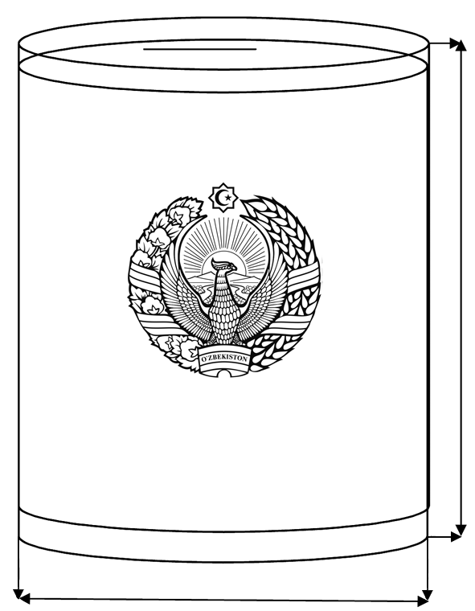100 cm

60 cm

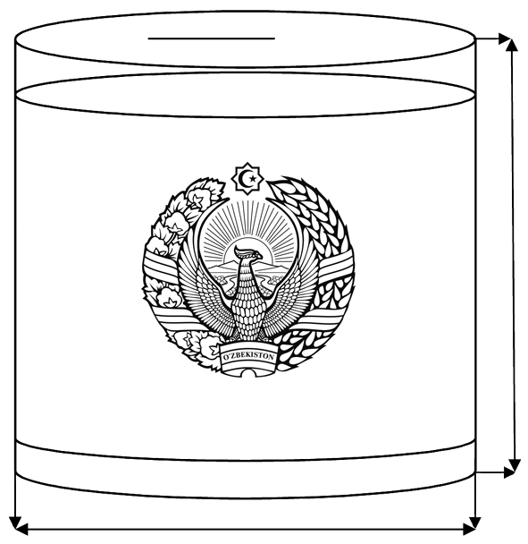50 cm

60 cm

**MOBILE ELECTION BOXES**

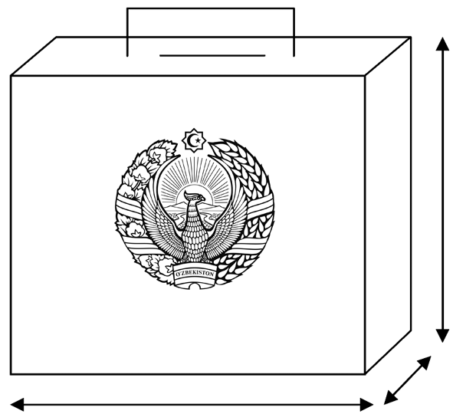35 cm

20 cm

30 cm

Mobile ballot boxes are designed for voting outside of the building.

Dimensions of portable ballot boxes for voting should be 30 x 20 x 35 cm.

Number of mobile ballot boxes for early voting shall be determined by the decision of the appropriate precinct election commission and each of them shall be assigned a serial number.

Ballot boxes shall be under control of members of the precinct election commission and observers from the moment they are sealed until they are opened.

Control over the storage of ballot boxes shall be entrusted to a member of the precinct election commission determined by the decision of the commission.

ANNEX 6

to the Regulation on the procedure for organizing activities of precinct election commissions to conduct elections of the President of the Republic of Uzbekistan

**SECRET VOTING ROOM WITH LARGE AREA**

**INFORMATION STAND**

**Secret ballot booth**

**Observers, media representatives**





**EX I T**

**EN T RANCE**

В













**VOTER LIST**

###### Issue of ballot papers

**PRECINCT ELECTION COMMISSION MEMBERS**

**SECRET VOTING ROOM WITH SMALL AREA**

**INFORMATION STAND**

**АХБОРОТ СТЕНДИ**

**Observers, media representatives**

**Secret ballot booth**

**ENTRANCE and EXIT**

**BALLOT BOX**

**VOTER LIST**

###### Issue of ballot papers

**PRECINCT ELECTION COMMISSION MEMBERS**

ANNEX 7

to the Regulation on the procedure for organizing activities of precinct election commissions to conduct elections of the President of the Republic of Uzbekistan

**DRAWING OF SECRET VOTING BOOTHS**

Secret ballot box shall be set up in a way to prevent the voter from observing the secret balloting by those present in the room where it is located and to allow him/her to freely express his/her will.

The cabin should be 2 meters high and 0.75 meters wide.

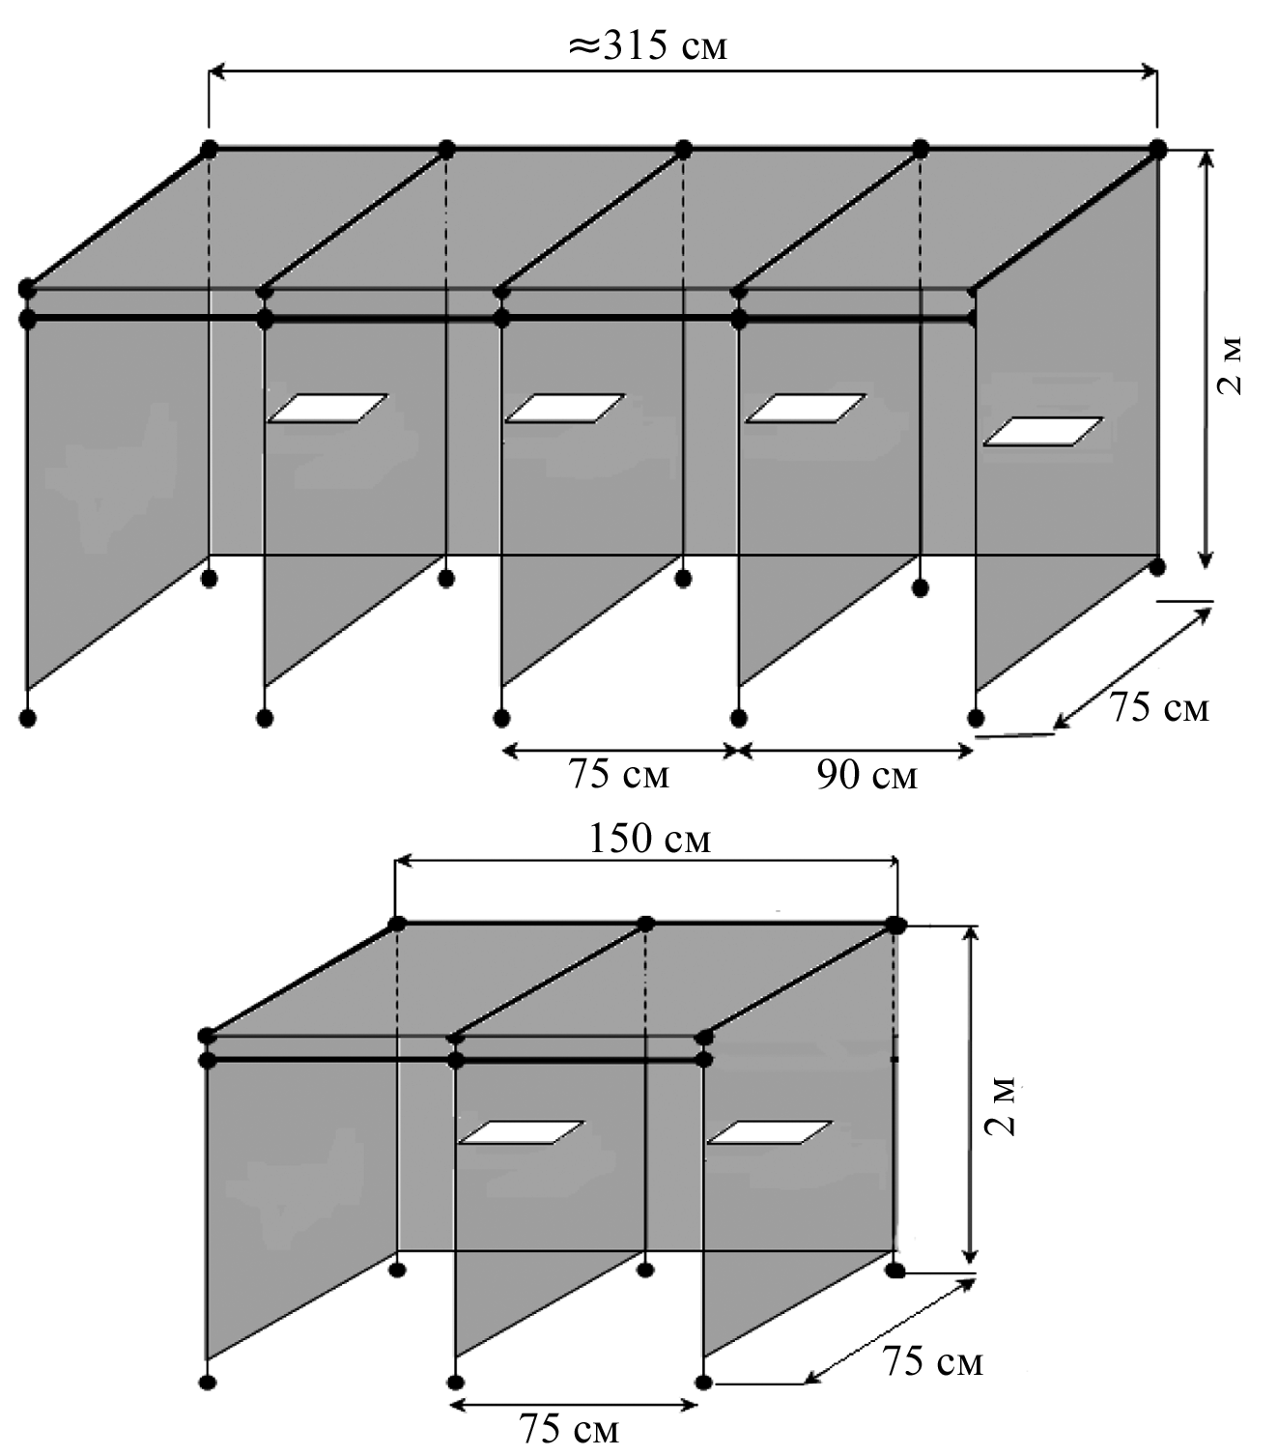

**MOBILE VOTING BOOTH**

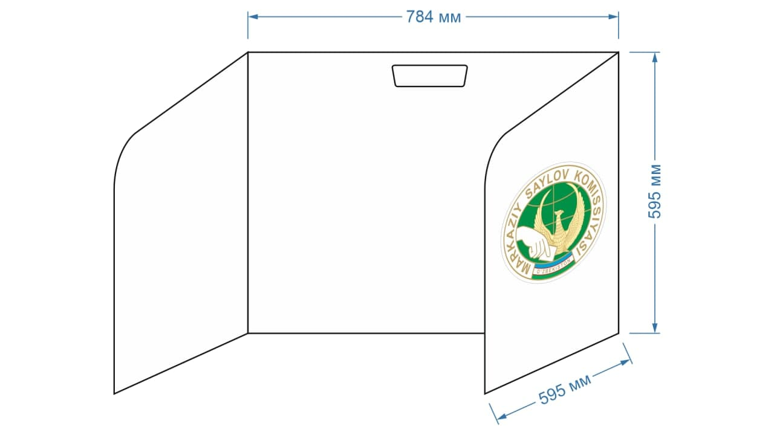

ANNEX 8

to the Regulation on the procedure for organizing activities of precinct election commissions to conduct elections of the President of the Republic of Uzbekistan

**SAMPLE**

**of rubber seal of the precinct election commission**

**d-35 mm**

**\***

**U CH A S T K A S A Y L O V K O M I S S I Y A S I**

**\***

**T O SH K E N T SH A H A R**

**242**

Rubber seal of the precinct election commission is round-shaped with a diameter of 35 mm with the main circle at a distance of 17.5 mm from the center and another circle at a distance of 1 mm. There is writing “Precinct Election Commission *”* below the second circle; right below it, there is writing “Tashkent city *”*. Below the text there is another inner circle 0.8 mm from the center, there is a number of the precinct election commission inside of it.

*\* Number of the precinct election commission to conduct election of the President of the Republic of Uzbekistan shall be approved by the appropriate district election commission.*

*ANNEX 8а*

**Polling station plaque**

**POLLING STATION #254**

**for election of the President of the Republic of Uzbekistan**

80 cm

150 cm

*ANNEX 8b*

**Information stand about the precinct election commission**

|  |  |  |  |  |  |  |  |  |  |
| --- | --- | --- | --- | --- | --- | --- | --- | --- | --- |
| |  |  |  |  |  |  |  |  |  | | --- | --- | --- | --- | --- | --- | --- | --- | --- | | Polling station map and work schedule of the precinct election commission |  | Members and telephone numbers of the precinct election commission |  | Precinct election commission duty schedule and voting procedure |  | Work plan of the precinct election commission |  | Hotlines | |

120 cm

240 cm

**Note:** The height of the lower border of the stand above ground level should be at least 80 cm.

*ANNEX 8c*

**Stand with biographies of the candidates**

|  |  |  |  |  |  |  |  |  |  |
| --- | --- | --- | --- | --- | --- | --- | --- | --- | --- |
| **CANDIDATES FOR THE PRESIDENT OF THE REPUBLIC OF UZBEKISTAN**   |  |  |  |  |  |  |  |  |  | | --- | --- | --- | --- | --- | --- | --- | --- | --- | | А2  Width 42 cm  Height 59.40 cm |  | А2  Width 42 cm  Height 59.40 cm |  | А2  Width 42 cm  Height 59.40 cm |  | А2  Width 42 cm  Height 59.40 cm |  | А2  Width 42 cm  Height 59.40 cm | |

120 cm

240 cm

**Note:** Height of the lower border of the stand above ground level should be at least 80 cm.

*ANNEX 8d*

**VOTER LIST STAND**

|  |
| --- |
|  |

165 cm

240 cm

**Note:** Height of the lower border of the stand above ground level should be at least 60 cm.

Depending on the number of voters, two stands can be prepared.

ANNEX 9

to the Regulation on the procedure for organizing activities of precinct election commissions to conduct elections of the President of the Republic of Uzbekistan

**Polling station indicator**

**POLLING STATION #254**

25 cm

75 cm

ANNEX 10

to the Regulation on the procedure for organizing activities of precinct election commissions to conduct elections of the President of the Republic of Uzbekistan

**ELECTION OF THE PRESIDENT OF THE REPUBLIC OF UZBEKISTAN**

**EXTRACT FROM VOTER LIST**

(on voters who voted early)

election precinct #______

«___»_______________ 20__

*(election date)*

**ELECTION PRECINCT __________**

(location of the election precinct - village, aul, settlement, city, district, region, military unit)

|  |  |  |  |  |
| --- | --- | --- | --- | --- |
| **#** | **Last name, first name, patronymic** | **Year of birth** | **Place of residence** | **Voter's signature on receipt of a ballot paper** |
| 1 | 2 | 3 | 4 | 5 |
|  |  |  |  |  |
|  |  |  |  |  |
|  |  |  |  |  |
|  |  |  |  |  |
|  |  |  |  |  |
|  |  |  |  |  |
|  |  |  |  |  |
|  |  |  |  |  |

*\*) Voters who turn 18 on election day - indicate the day and month of birth.*

**Note**: Voter information can be recorded into this list with a pen.

ANNEX 11

to the Regulation on the procedure for organizing activities of precinct election commissions to conduct elections of the President of the Republic of Uzbekistan

*Sample of the act of distribution of ballot papers to the members of the precinct election commission*

**ACT**

**of the precinct election commission #____ for election of the President of the Republic of Uzbekistan**

20 ___ October Tashkent city

This act is drawn up between the chairman and a member of the precinct election commission on transfer and receipt of ballot papers.

________ ballot papers for the election of the President of the Republic of Uzbekistan are handed over and received.

**Chairman of the precinct election commission #** **:** ______________________________

*(last name, first name, patronymic)*

**Transferred** ______________

*(signature)*

**Member of the precinct election commission #** **:** _____________________________

*(last name, first name, patronymic)*

**Accepted** ______________

*(signature)*

ANNEX 12

to the Regulation on the procedure for organizing activities of precinct election commissions to conduct elections of the President of the Republic of Uzbekistan

*Sample act for sealing a ballot box*

**ACT**

**of the precinct election commission #____ for election of the President of the Republic of Uzbekistan**

October, 20__ Tashkent city

Participants: Members of the Precinct Election Commission

This act is signed in acknowledgement of sealing of a ballot box.

In accordance with the procedure established by the Central Election Commission of the Republic of Uzbekistan, ballot boxes are sealed with seals # __________, # __________, #________ and mobile portable box with seal #__________.

**Chairman of the precinct election commission #** **:** _____________________ _____________________ *(last name, first name, patronymic)*

______________

*(signature)*

**Secretary of the precinct election commission #** **:** _____________________

*(last name, first name, patronymic)*

______________

*(signature)*

ANNEX 13

to the Regulation on the procedure for organizing activities of precinct election commissions to conduct elections of the President of the Republic of Uzbekistan

**ELECTION OF THE PRESIDENT OF THE REPUBLIC OF UZBEKISTAN**

**EXTRACT FROM VOTER LIST**

*(on voters who voted at their place of residence)*

election precinct # ______

«___» _______________ 20___

*(date of election)*

**ELECTION PRECINCT __________**

*(location of the election precinct - village, aul, settlement, city, district, region, military unit)*

|  |  |  |  |  |
| --- | --- | --- | --- | --- |
| **#** | **Last name, first name, patronymic** | **Year of birth** | **Place of residence** | **Voter's signature on receipt of a ballot paper** |
| 1 | 2 | 3 | 4 | 5 |
|  |  |  |  |  |
|  |  |  |  |  |
|  |  |  |  |  |
|  |  |  |  |  |
|  |  |  |  |  |
|  |  |  |  |  |
|  |  |  |  |  |
|  |  |  |  |  |

*\*) Voters who turn 18 on election day - indicate the day and month of birth.*

**Note:** Voter information can be recorded into this list with a pen.

ANNEX 14

to the Regulation on the procedure for organizing activities of precinct election commissions to conduct elections of the President of the Republic of Uzbekistan



**ELECTION OF THE PRESIDENT OF THE REPUBLIC OF UZBEKISTAN**

«___»___________ 20____

**PROTOCOL**

**OF THE PRECINCT ELECTION COMMISSION ON THE RESULTS OF COUNTING THE VOTES AT THE POLLING STATION**

In accordance with Articles 24, 54, 94 of the Electoral Code of the Republic of Uzbekistan, the precinct election commission determined the following as a result of counting of votes in electoral precinct _____ of the electoral district _____ :

1. Total number of voters of the electoral precinct ____________
2. Number of ballots received by the precinct election commission ____________
3. Number of voters who received ballot papers ____________
4. Number of voters participated in early voting ____________
5. Number of voters who took part in voting

(ballot papers in ballot boxes) ____________

1. Total number of unused and spoiled and canceled ballot papers____________
2. Number of votes for each candidate: ____________

|  |  |  |  |
| --- | --- | --- | --- |
| **#** | **Last name, first name, patronymic of candidates for the President of the Republic of Uzbekistan**  *(in alphabetical order)* | **Number of votes cast for a candidate for President of the Republic of Uzbekistan** | **Name of the political party that nominated the candidate for the President of the Republic of Uzbekistan** |
| 1. |  |  |  |
| 2. |  |  |  |
| 3. |  |  |  |
| 4. |  |  |  |
| 5. |  |  |  |

1. Number of invalid ballot papers is _________________

**Chairman of the Commission** ______________________________ ____________

*(last name, first name, patronymic)* *(signature)*

**Deputy Chairman of the Commission** ________________________ ____________

*(last name, first name, patronymic)*  *(signature)*

**Secretary of the Commission** _______________________________ ____________

*(last name, first name, patronymic)* *(signature)*

**Commission members:**

_______________________________________________________ ____________

*(last name, first name, patronymic) (signature)*

_______________________________________________________ ____________

*(last name, first name, patronymic) (signature)*

_______________________________________________________ ___________

*(last name, first name, patronymic) (signature)*

_______________________________________________________ ___________

*(last name, first name, patronymic) (signature)*

_______________________________________________________ ____________

*(last name, first name, patronymic) (signature)*

_______________________________________________________ ____________

*(last name, first name, patronymic) (signature)*

_______________________________________________________ ____________

*(last name, first name, patronymic) (signature)*

_______________________________________________________ ____________

*(last name, first name, patronymic) (signature)*

_______________________________________________________ ____________

*(last name, first name, patronymic) (signature)*

_______________________________________________________ ____________

*(last name, first name, patronymic) (signature)*

_______________________________________________________ ____________

*(last name, first name, patronymic) (signature)*

_______________________________________________________ ____________

*(last name, first name, patronymic) (signature)*

_______________________________________________________ ____________

*(last name, first name, patronymic) (signature)*

_______________________________________________________ ____________

*(last name, first name, patronymic) (signature)*

_______________________________________________________ ____________

*(last name, first name, patronymic) (signature)*

_______________________________________________________ ____________

*(last name, first name, patronymic) (signature)*

Protocol is prepared on “_____” _______ 20___ . SEAL

*NOTE!*

*The first copy of the protocol shall be sent to the district election commission in accordance with the established procedure.*

*The first copy of the protocol shall be accompanied by a list of observers from political parties that nominated a candidate for President of the Republic of Uzbekistan and citizens' self-government bodies as well as representatives of mass media, other countries and international organizations.*

*The second copy of the minutes shall contain the separate opinions of the members of the commission (if any); requests on shortcomings in voting or counting of votes, decisions of the commission on these requests; act on sealing of ballot boxes; ballot papers with other election related documents shall be kept by the precinct election commission.*

*The number specified in paragraph 5 of the Protocol #___ shall be equal to the sum of the numbers in lines 1, 2, 3, 4 and 5 and in paragraph 8 of the Protocol (paragraph 5 = sum of lines in paragraph 7 + paragraph 8).*